TASK-1 LINUX:- ensure the script checks if a specificfile exists in the current directory . if exists , print exists, other wise not found.

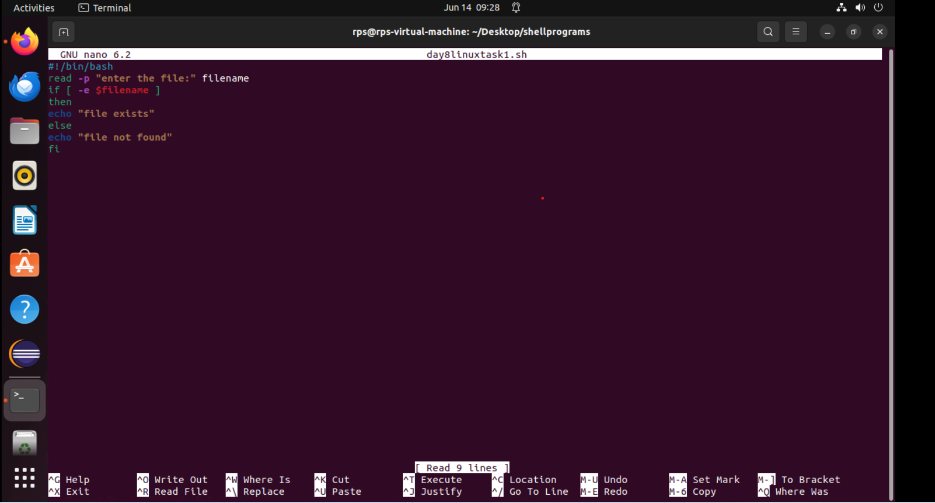

**Output:**

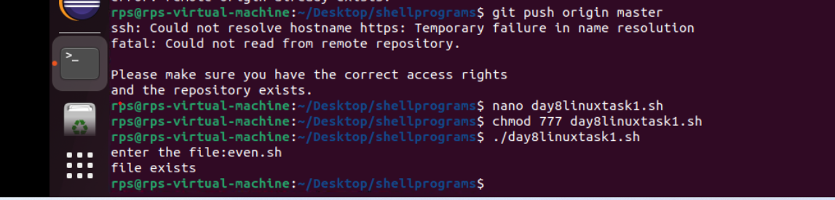

Task2:- write a script thaht read numbers from user until we enter 0. The script should print whether the num is even r odd.

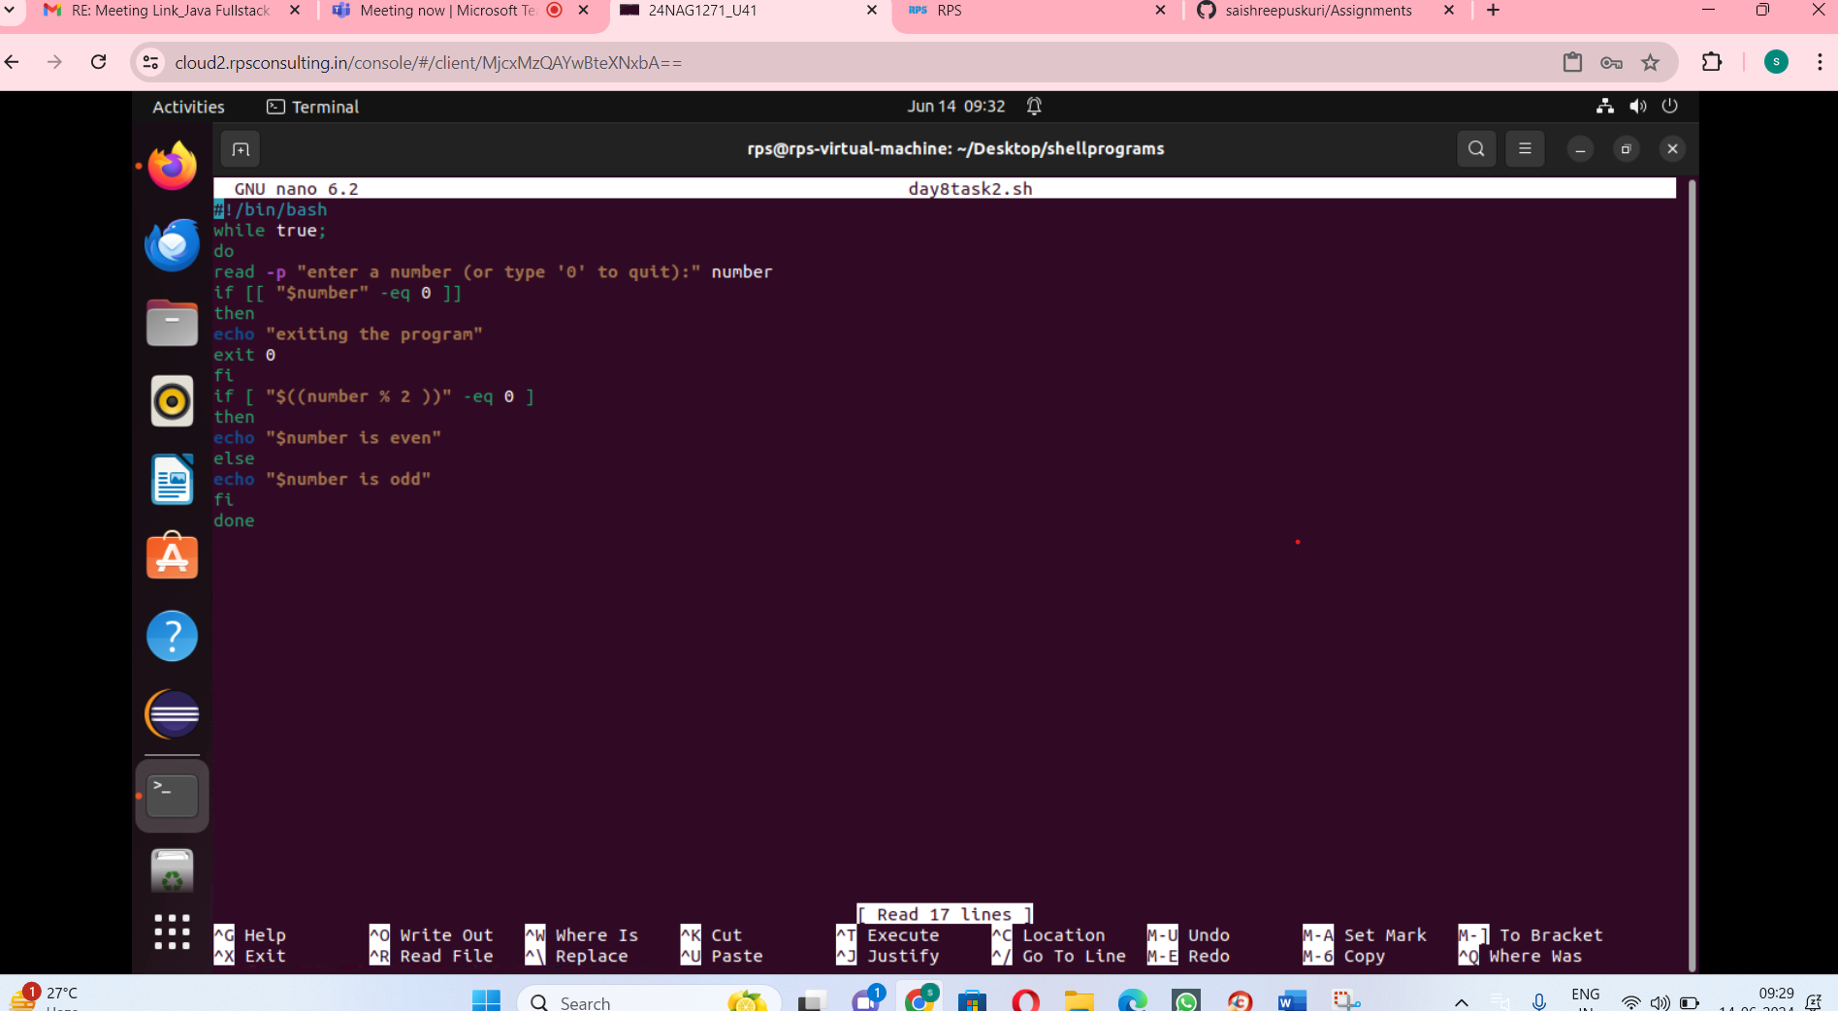

Output:-

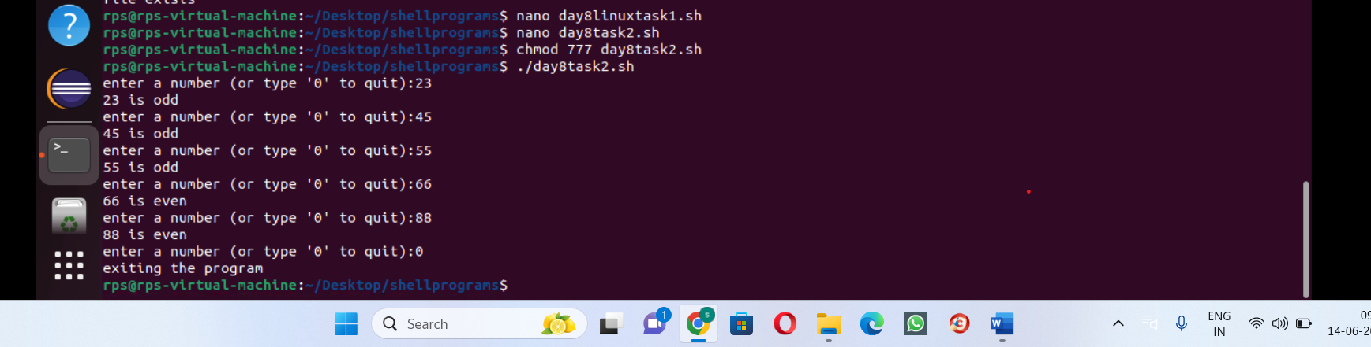

Task-3:- create a function that makes filename as argument and prints the number of lines in the file . call this function from ur script with different names.

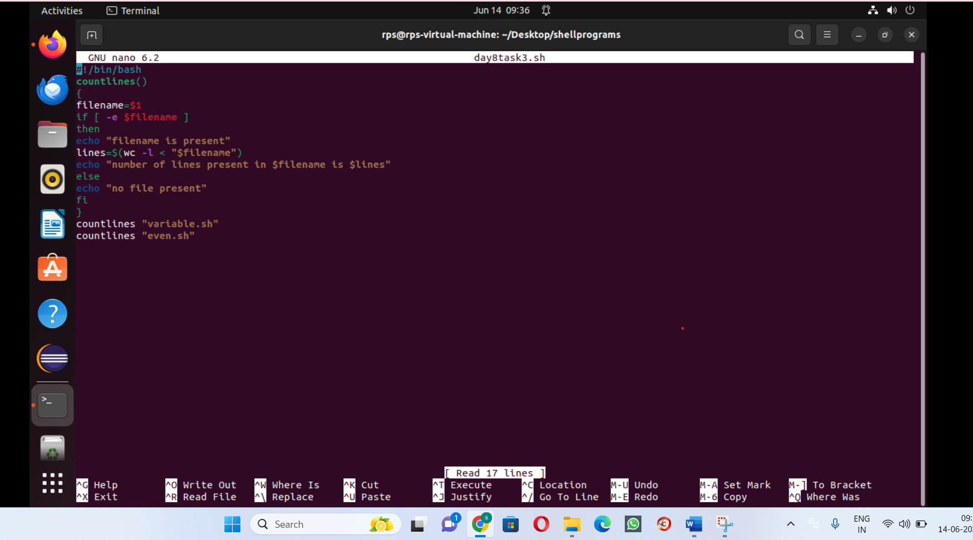

Output:-

